STM Product Attachments — File Downloads, Previews & Auto-Assign Rules for Products
User Guide
Attach files, organise them in categories, preview them inline, and assign them at scale — on Magento 2 / Adobe Commerce.

Overview
STM Product Attachments adds a dedicated attachments tab to every product on your Magento 2 / Adobe Commerce store. Shop owners can upload files on the product edit page, mass-assign from the product grid, bulk-import via CSV or let a rule engine attach files automatically. Customers see an Attachments tab on the product page with thumbnails, colour-coded file-type badges, file size, download counter and an inline preview modal for PDFs, images, YouTube videos and direct video files.
The extension is configuration-driven, translatable and compatible with Luma-based themes. All admin settings are scope-aware down to the store-view level.

Adding Attachments on a Product
Open any product under Catalog > Products. A new Product Attachments collapsible block appears on the product edit page. Click Add Attachment, upload a file (or paste a YouTube URL), enter a title, optionally assign a category and set the sort order. Save the product.

Central Attachment Management
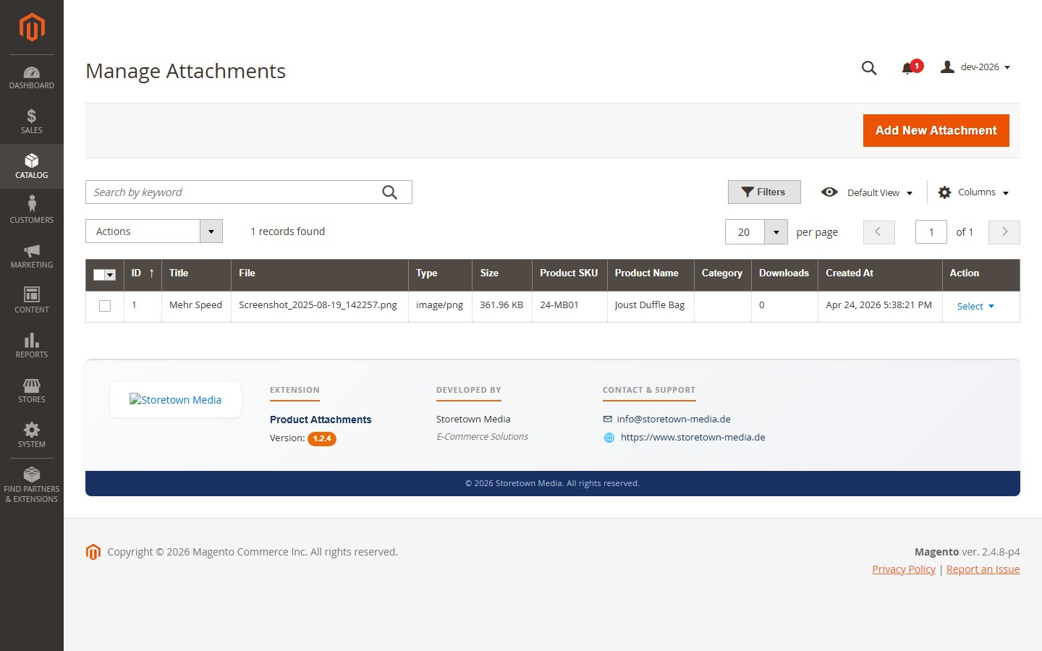
All attachments across all products are available as a grid under Catalog > Product Attachments > Manage Attachments. The grid supports column filters, full-text search and pagination. Mass actions include Mass Delete and Mass Category Assign.
Figure 1. Central attachment grid under Catalog > Product Attachments > Manage Attachments.

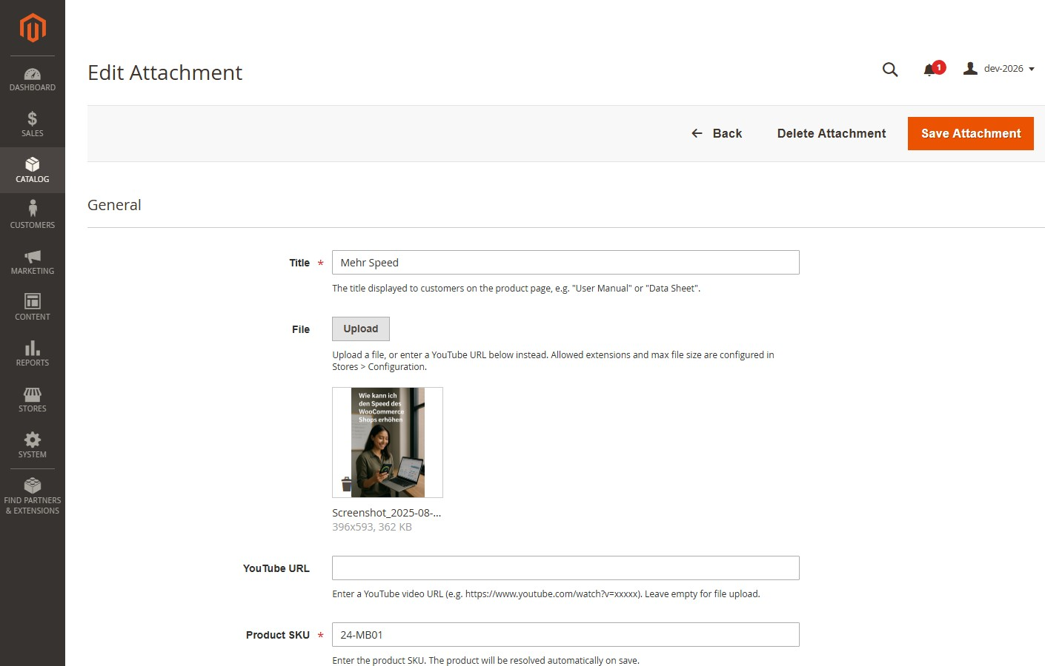
Figure 2. Attachment edit form — file upload, YouTube URL, title, category, sort order and per-store-view visibility.

Mass Assign from the Product Grid
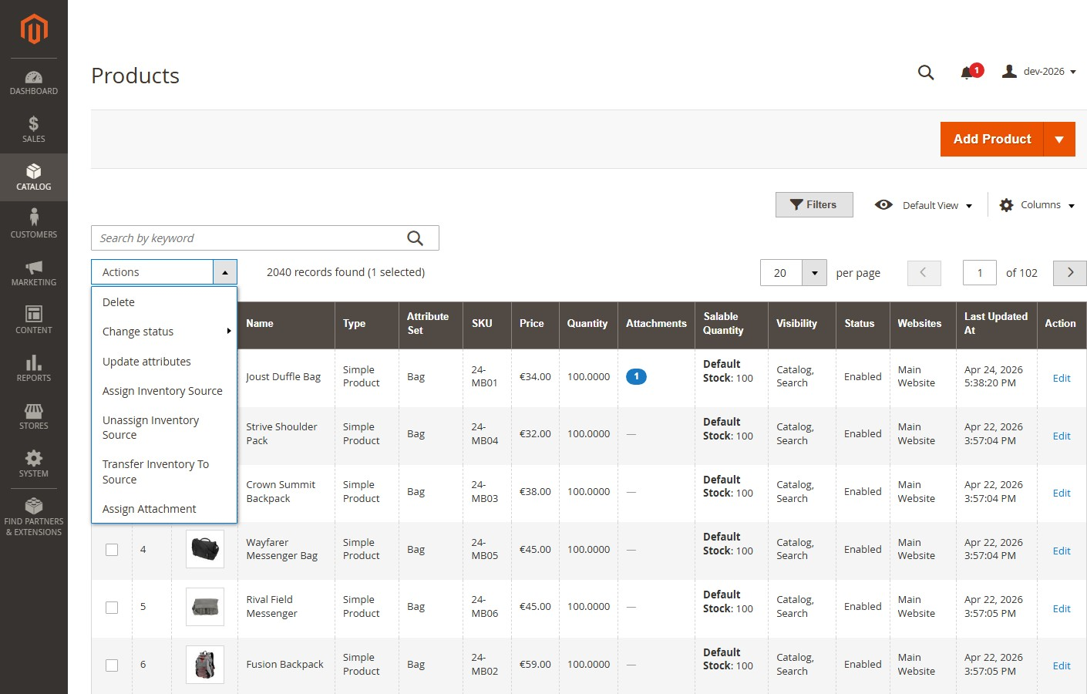
Select any number of products in Catalog > Products, open the Actions dropdown and choose Assign Attachment. The form that opens has a drag-and-drop file dropzone and captures title and sort order. On submit, the same file is attached to all selected products in a single batch — useful for product documents that apply to a whole brand, collection or safety class.
Figure 3. Assign Attachment mass action in the catalog product grid.

CSV Import
For larger rollouts, use Catalog > Product Attachments > Import Attachments. Prepare a CSV with the columns sku, title, file_path (required) and category, sort_order (optional), upload your attachment files to pub/media/import/attachments/, then pick the CSV and click Import. Validation errors are reported per row.

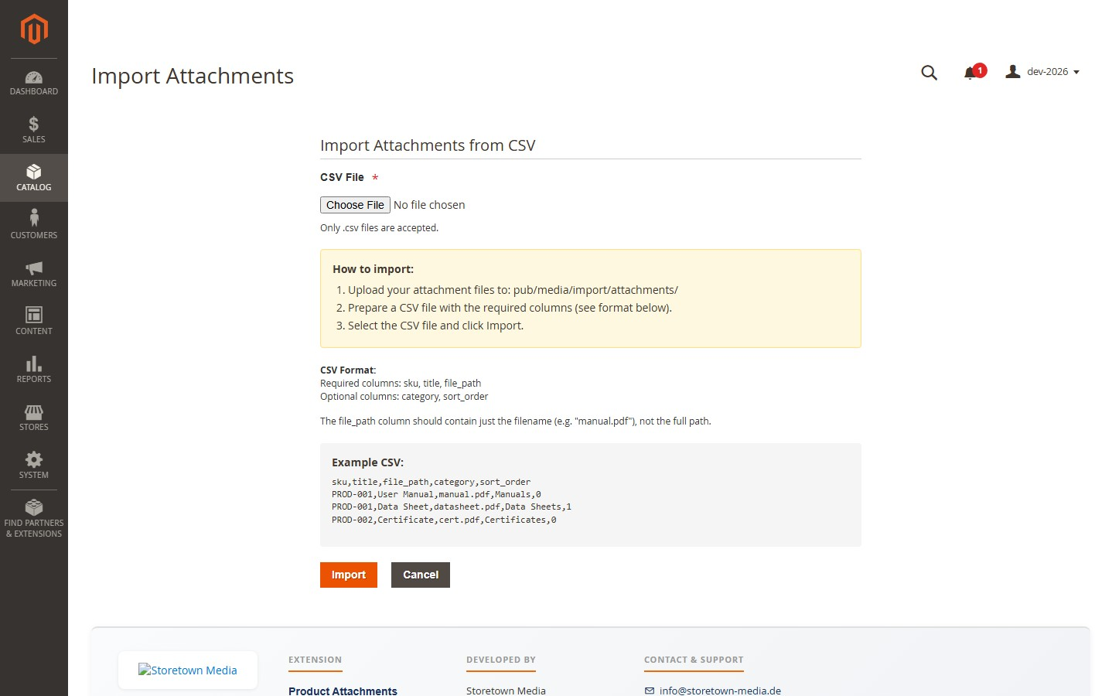
Figure 4. CSV import form with step-by-step instructions and format reference.

Attachment Categories
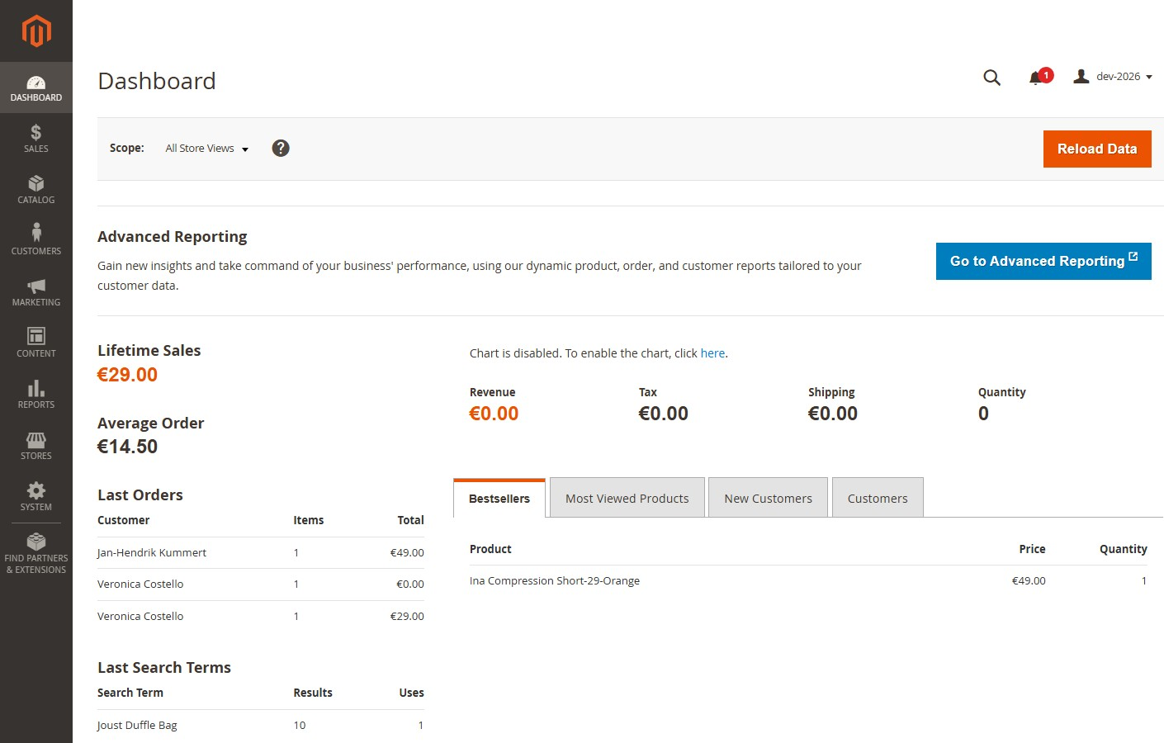
Attachment categories organise your documents (Manuals, Data Sheets, Certificates, Safety Information …) and drive the grouping on the product detail page when Group by Category is enabled. Manage them in the Attachment Categories grid of the system configuration.
Figure 5. Attachment categories grid.

Auto-Assign Rules
For repetitive assignments at scale, use the rule engine under Catalog > Product Attachments > Auto-Assign Rules. A rule defines one file plus a set of conditions on product category, attribute set or any product attribute. Conditions combine via AND or OR. Each rule can be applied on save, run nightly via cron, or triggered manually from the grid. After apply, the Full Page Cache is flushed automatically so the storefront reflects the change immediately.

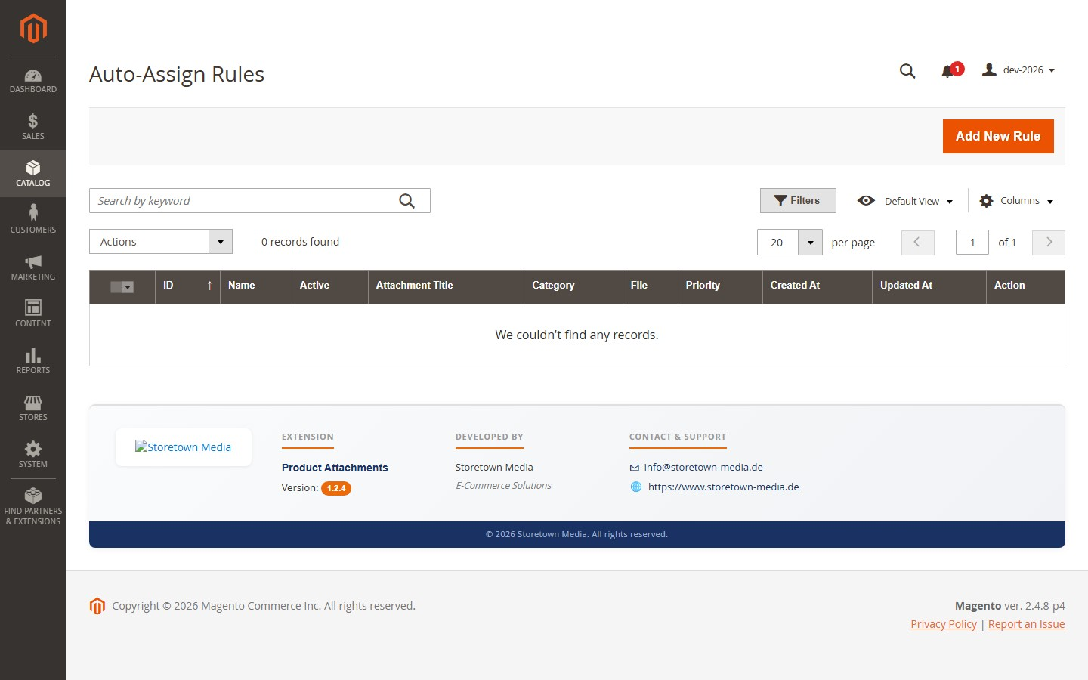
Figure 6. Auto-Assign Rules grid — status, conditions summary, last-applied timestamp and apply action per rule.

Storefront Experience
On the product detail page, attachments appear in a new Attachments tab alongside Details and Reviews. Each row shows a thumbnail or colour-coded file-type badge, the title, file size, download count and two actions: Preview (opens an inline modal) and Download. The preview modal supports PDFs (embedded iframe), images, YouTube videos and direct video files — no external viewer required.

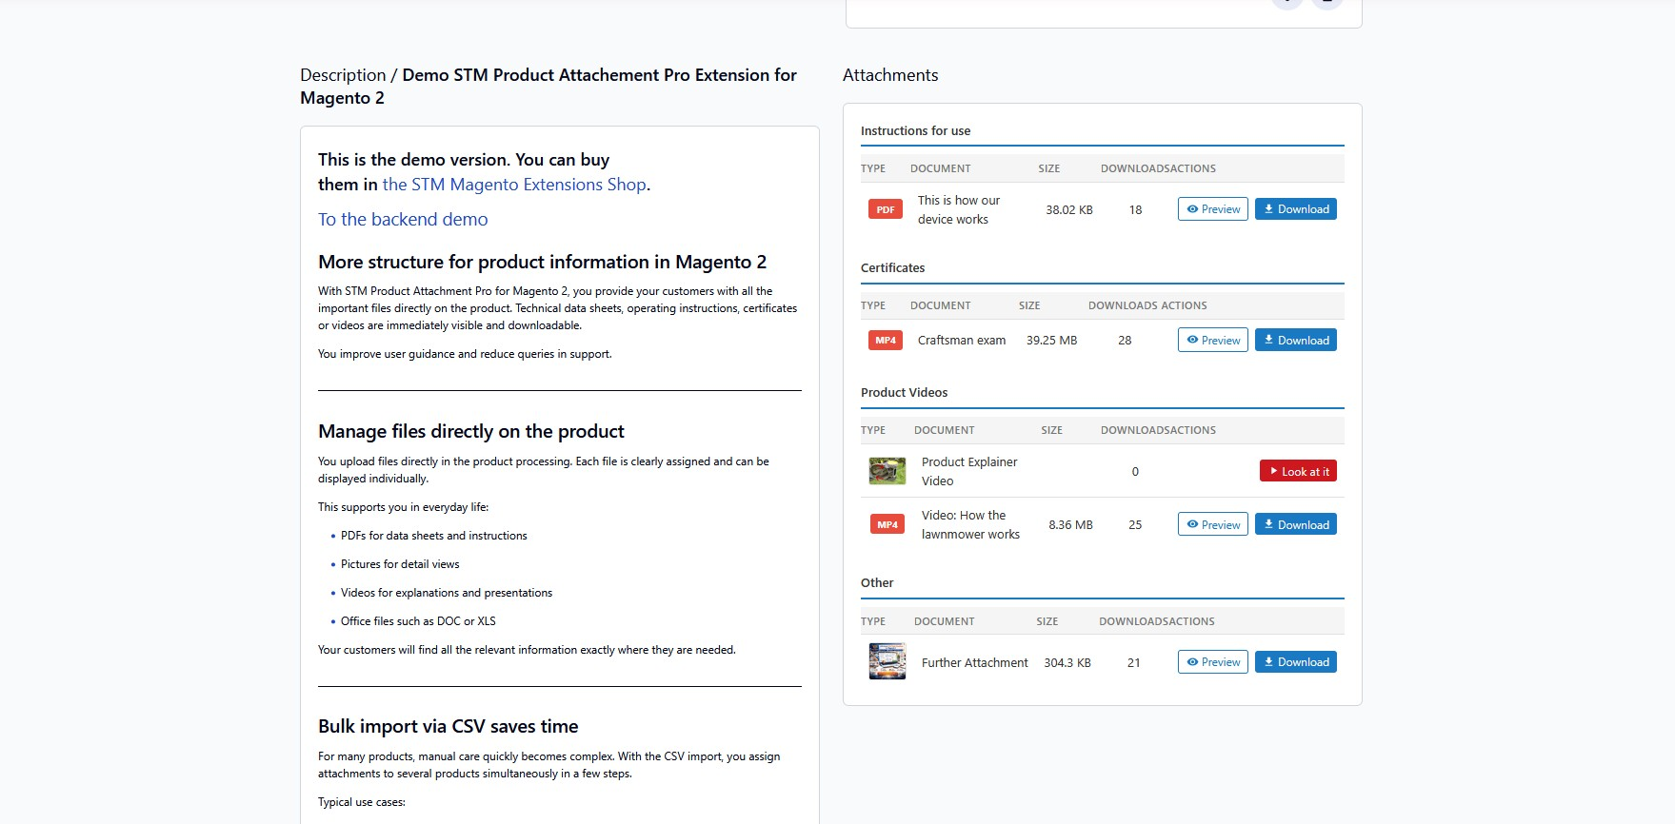
Figure 7. Frontend attachments tab with an open inline preview modal.

Administrative Configuration
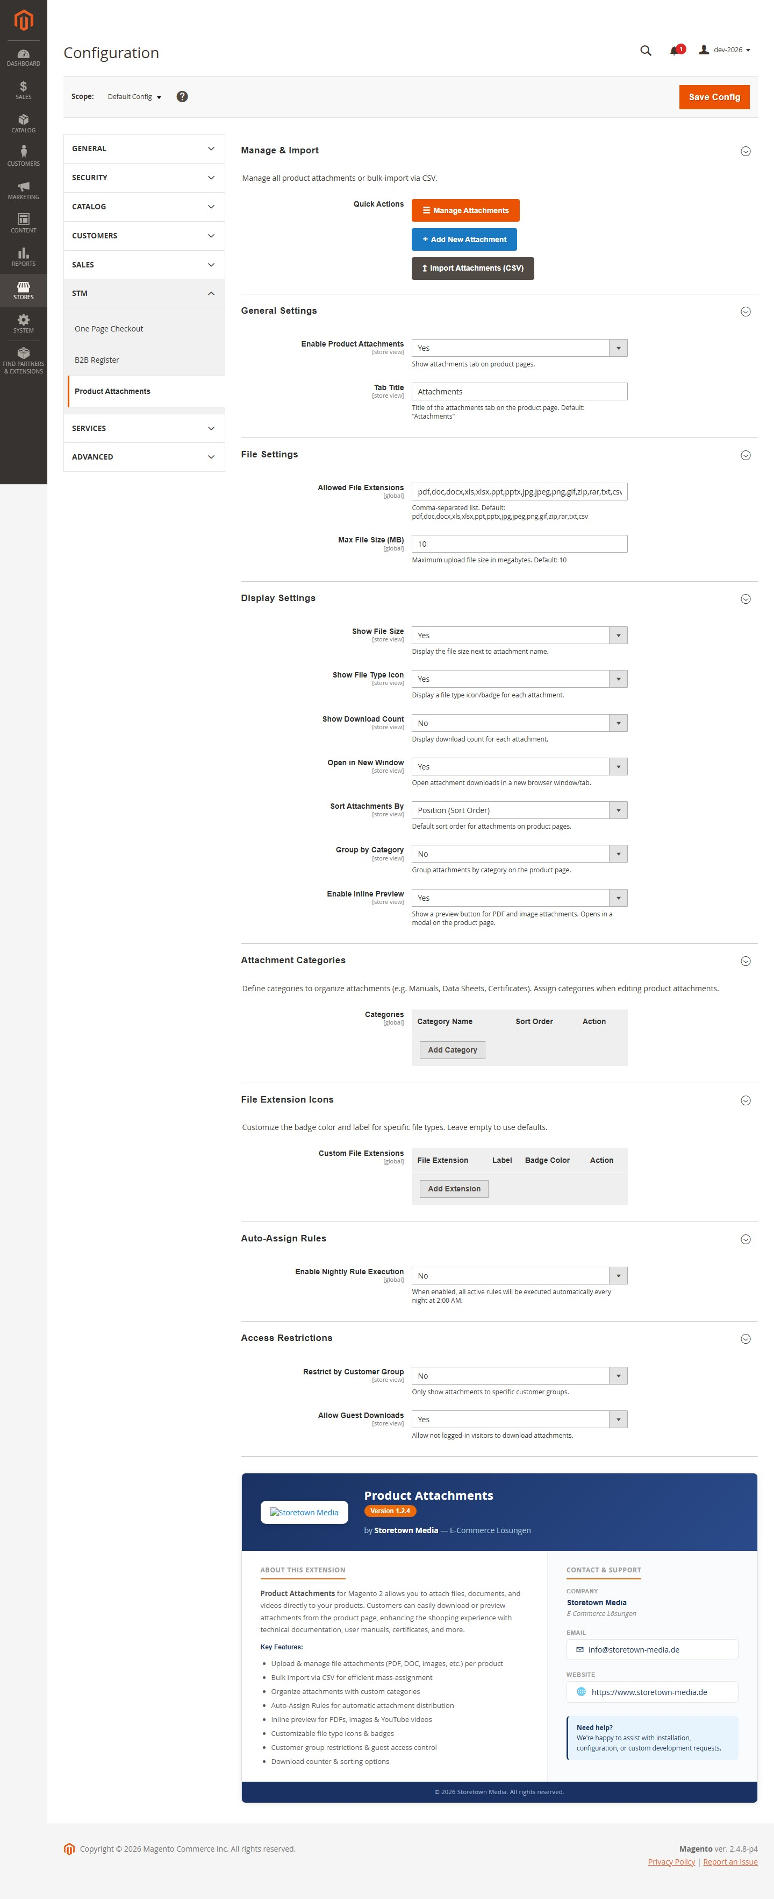
All settings live under Stores > Configuration > STM > Product Attachments and are scope-aware down to the store-view level.

Figure 8. Configuration overview — all groups expanded.

- Manage & Import — quick-action buttons to the manage grid and the import form.

- General — module toggle, tab title and tab sort order.
- File — allowed file extensions and maximum file size (MB).
- Display — show / hide file size, type icon, download count; open in new window; sort order; group by category; enable inline preview.
- Attachment Categories — inline grid of category names and sort orders.
- File Extension Icons — dynamic rows for custom file-type icons, labels and badge colours.
- Auto-Assign Rules — enable the nightly cron run for all active rules.
- Access Restrictions — restrict attachments to specific customer groups and control guest downloads.

Internationalization
English is the base language. A German translation (i18n/de_DE.csv) is included. All user-facing strings are fully translatable via the standard Magento CSV format — drop additional files into the i18n/ directory.

Support
Support is provided by Storetown Media through the Adobe Commerce Marketplace support link on this listing. Expected response time is within two business days.

